18.60: (Neglect the thermal expansion of the flask.) a) 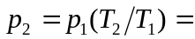

b) 